Windows 10 Taskbar Not Working FIX

**Rezolvarea prin PowerShell**

1. **Ne asiguram ca serviciul Windows Firewall este pe auto.**
2. **Pornim PowerShell-ul cu drepturi de administrator.**
3. **Dupa ce ne asiguram ca avem drepturi de administrator putem sa introducem comanda in PowerShell:**

Get-AppXPackage -AllUsers | Foreach {Add-AppxPackage -DisableDevelopmentMode -Register "$($_.InstallLocation)\AppXManifest.xml"}

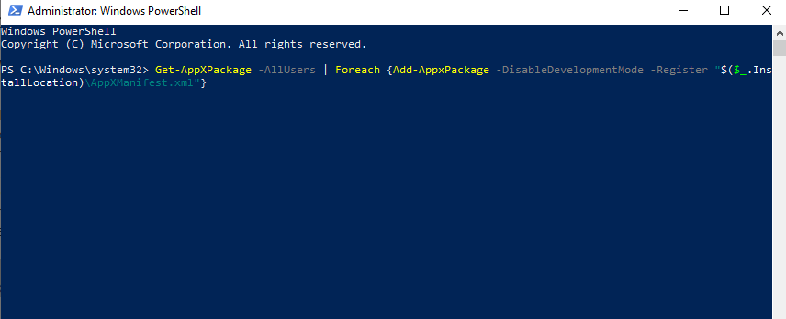

1. **Resetam calculatorul.**